Summary of 2015 Aging Well Progress 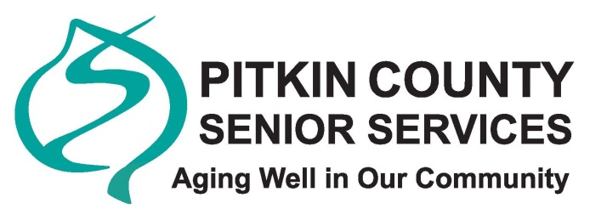
The Aging Well Community Planning Initiative outlines 13 community-wide goals to meet the needs and desires of seniors living in the community. The plan includes an anticipated timeline for beginning each action step. As this is a community plan, there are not necessarily measurable outcomes defined for each item, but Senior Services is tracking what happens with each item, and when. In 2015, the first year of the plan’s implementation, Senior Services and its community partners accomplished more than was projected in the plan’s timeline.
Senior Services has been amazed how the community has embraced the Aging Well Plan, and more importantly, embraced its mission: to make Pitkin county an exemplary place for aging well. Through this process, Senior Services has strengthened its many partnerships throughout the community. Organizations like the Aspen Recreation Center, Colorado Mountain College and the Aspen Art Museum are enhancing their offerings designed for older adults.
By simply bringing awareness to the community and shaping the senior discussion, the Aging Well plan has become the tide, rising to lift all boats carrying Pitkin County’s seniors.
Some Aging Well highlights from 2015:
- Initiated new volunteer drivers for seniors program as a project of Roaring Fork Leadership, a collaborative effort with Eagle County Healthy Aging in El Jebel. Will serve the entire valley with an emphasis on mid-valley transportation needs.
- Committees and task forces formed to address issues such as senior housing needs and access to wellness services and programs.
- A senior council member spearheaded a community-wide discussion event around the book “Being Mortal” highlighting end of life care needs for both seniors and their loved ones.
- Community health care partners met to discuss/address health care access challenges in the valley, particularly for Medicare and Medicare patients
- Aging Well leadership met with Pitkin County Caucuses to reaffirm availability of Senior Services staff to work with them on addressing needs of aging population in each region
- CMC nursing students are now providing foot care clinics at Senior Services, after another provider pulled out
- MindSprings began the process to train their staff and the staff of community partners in the mental/behavioral/cognitive health issues for older adults
- A Wellness Committee formed to improve access to Nutrition, Social Interaction, Physical Fitness & Recreation, Brain Fitness and Spirituality for seniors. This active group is meeting regularly and hosting a variety of events.
- The Aspen Art Museum has an ongoing schedule of events dedicated to seniors, which take place both at the Senior Center and the Museum
- The Senior Services Council undertook an outreach effort with a presence at an Aspen Saturday Market in mid-August. This energetic booth staffed by council members and high school students attracted a large number of community members and visitors of all ages – and really got the word out about Senior Services
- CMC initiated a computer class specialized for the “Pre-Tech Generation.” This ongoing free class will be held weekly.

